**ASSIGNMENTS ON DIGITAL MARKETING**

**NAME:** VISHNU PRIYA.R

**DEPARTMENT:** B.E BIOMEDICAL ENGINEERING

**NAANMUDHALVAN COURSE:** DIGITAL MARKETING

**NM ID:** DBA816327E2F626A62045F4FBAE0E9B8

**COLLEGE: 8151-** DHANALAKSHMI SRINIVASAN INSTITUTE OF

TECHNOLOGY SAMAYAPURAM, TRICHY.

**ASSIGNMENTS DESCRIPTION**

1. Create the blog or website using blogspot and wordpress.customize the theme design and post new article with 500 words.

[**https://wordpress.com/posts/saraprostheticcentre.wordpress.com**](https://wordpress.com/posts/saraprostheticcentre.wordpress.com)

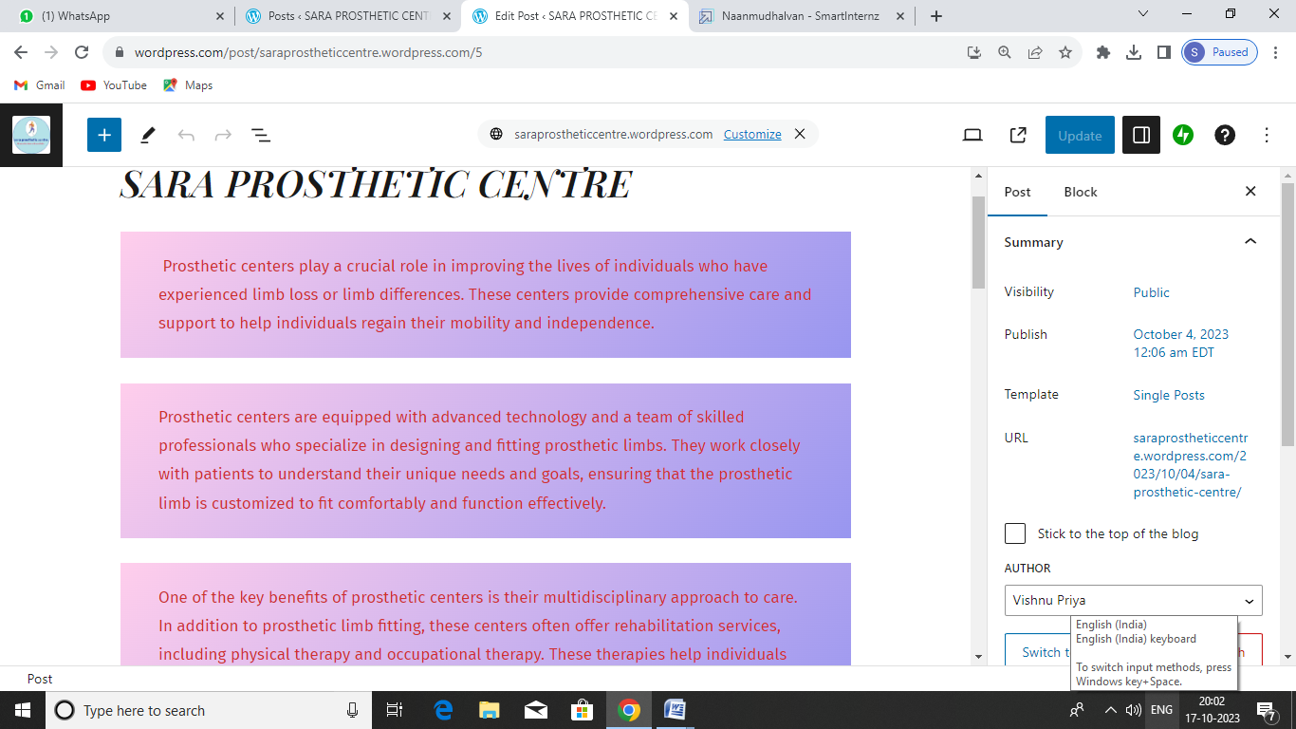

1. Create a new face book business page and post one social media poster for your brand.

<https://www.facebook.com/Saraprosthetic?mibextid=ZbWKwL>

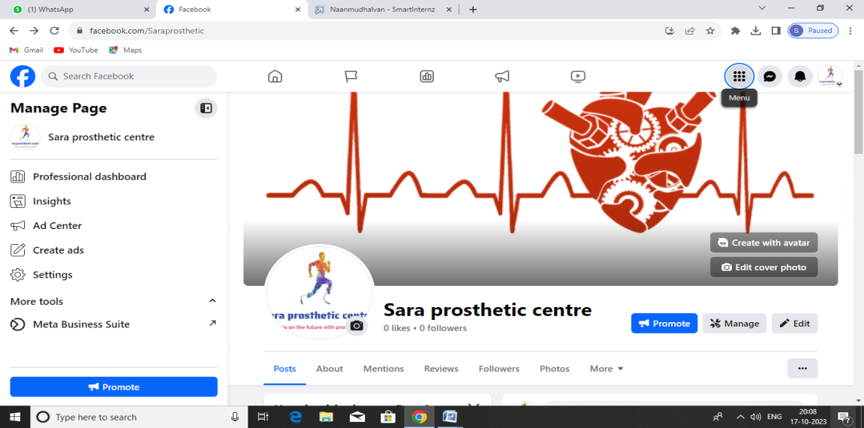

1. Create and design a social media advertisement poster using canva.

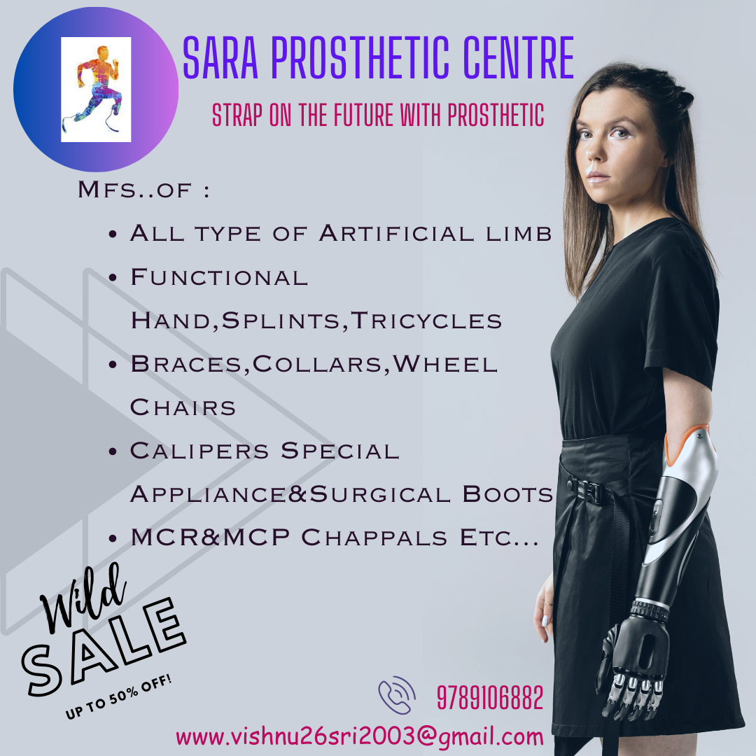

1. Create email newsletter design using mail chimp or canva tool.

